Student Placement Prediction Using Machine Learning

Numpy-> for numerical opn and arrays
Pansas for import lib. And see data
Matplotlib for graphical representation
Seaborn for stastical representation
LabelEncoder for text to number
train_test_split for training

LogisticRegression is for here we have binary type placed or not so..
DecisionTreeClassifier is a like if cgpa>7.5 ? yes then internship>1 if yes then placed
RandomForestClassifier Random Forest is a collection of many Decision Trees.
Df.head() first 5
.tail() last 5
.shape() show row and coloum like (10000,12)
.info() show row column column name datatype not null memory usage

.duplicate.sum() if duplicate then count and print

placement_data.describe().T
it prints mean max min std 25 50 75 in table (.T)

placement_data["PlacementStatus"].value_counts()
ketla placed tya chhe ae batavse

make simple model create encoder = LabelEncoder()
not train yet

placement_data["PlacementTraining"] = encoder.fit_transform(
placement_data["PlacementTraining"]
)
PlacementTraining ne label encode karyu (convert into 0 1 )

test_size=0.2, 20% test ma
random_state=42, take every 42th value
stratify=y every time give same answer not changed after trainng model

logistic_model = LogisticRegression(max_iter=1000) create logistic model

logistic_model.fit(X_train, y_train) and train it

confusion matric
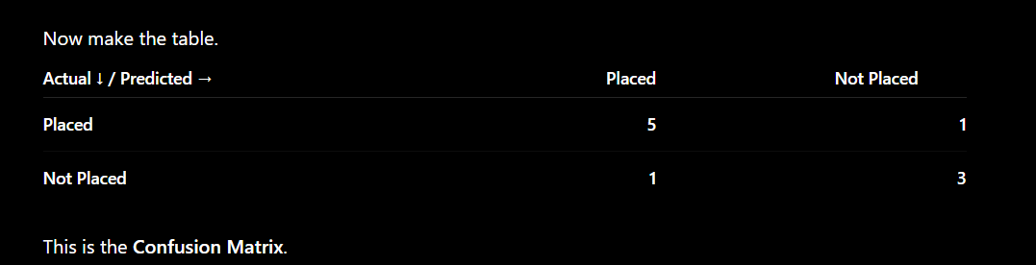

"A confusion matrix is a table that compares the model's predictions with the actual values. It shows how many predictions are correct and how many are incorrect. It helps us understand the types of errors made by the model, not just the overall accuracy."
# Classification Report
It gives more detailed about prediction/ accuracy It provides four important metrics:
Precision,-> model ae kidhu 100 placed but actual 90 so precision is 90%
Recall,-> model ae kidhu 100 but 120 actual so recall=100/120
F1-score, -> precision and recall nu balance if one more then f1 is high if one low then f1 low
Support->total sum of placed and not placed

